Final Project

Nicholas McKenzie 620111723

Derwent Johnson 620088317

Andrew-Lloyd Small 620109249

Kimberly Taylor 620106726

**Overview**

1. ER Diagram
2. Tables Before Normalization
3. Tables After Normalization
4. Functional Dependencies
5. Data Dictionary

**ER Diagram**

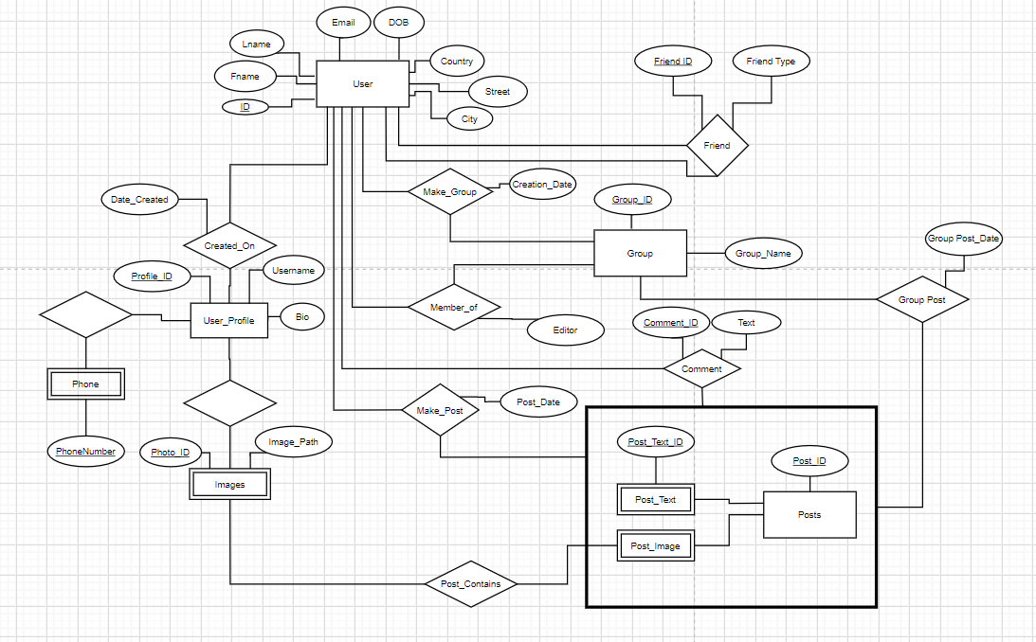

**Normalization**

**Tables Before Normalization**

User(user_id,name,email,username,address,dob,pnum)

Friend(user_id,friend_id,friend_type)

Profile(profile_id,user_id)

Make(useu_id,date_time)

Post(post_id,pbody,pimages,ptext)

Group(group_id,name,editor)

**Tables After Normalization**

User(id,fname,lname,email,username,password,,street,city,country,dob)

Friend(user_id,friend_id,friend_type)

Phone(id,phoneNumber)

Created_on(user_id,profile_id,date)

Profile(profileid,uid,date,bio,gid)

Comment(user_id,cid,ctext)

Make_post(user_id,post_id,date_time)

Posts(post_id,pbody,pimages,ptext)

Member_of(id,gid,editor)

Group(gid,cid,post_id,name)

Images(photo id,profile id,post_id,file)

Post_Contains(post_id,photo_id,text)

Make_group(user_id,group_id,creation_date)

**Functional Dependencies**

id→name,email,username,address,dofb

id,fid→ftype

id→pnum

id→date

id,cid→ctext

id→date_time

poid→pbody,pimages,ptext

id,gid→editor

gid→name

poid→images,text

**Data Dictionary**

**Tables**

|  |  |
| --- | --- |
| **Table Name** | **Description** |
| friend | Relationship between 2 users |
| user_profile | Profile information for each user. One user can have multiple profiles. |
| posts | These are posts created either by a user or a group. A post can contain either an image or just text, or both. |
| user | This table holds personal data about each user, along with a unique identifier. |
| phone | This table contains user identification and their phone number. A user can have zero or many phone numbers. |
| member_of | This table indicates the group/groups that a user is a part of, as well as whether or not they have editor privileges. |
| make_post | This table indicates the date a post was made by a user. |
| comment | Comments made by a user;describes when the comment was made, what was commented and on what posts |
| group | This table contains the name of the group a user is a member of and the group’s id. |
| images | This table contains information regarding the images stored in the user’s profile |
| make_group | This relationship is between a group and it’s creator. |
| group _post | This relationship is between a group and the various posts made in that group. |
| post_contains | This relationship supports posts that contain images, as such, it links the post_image to the image table. |
| created_on | This relationship links the user to a profile that they may have created. |
| post_image | This is a dependent in a isa relationship with post and supports images being a part of a post. |
| post_text | This is a dependent in a isa relationship with post and supports text being a part of a post. |

**Attributes**

User

|  |  |  |  |
| --- | --- | --- | --- |
| Field Name | Data Type | Field Size | Description |
| id | Integer | auto increment | User’s ID |
| fname | Varchar | 20 | User’s First Name |
| lname | Varchar | 20 | User’s Last Name |
| email | Varchar | 100 | User’s Email |
| password | Varchar | 255 | Password |
| street | Varchar | 100 | User’s Street |
| city | Varchar | 100 | User’s City |
| country | Varchar | 50 | User’s Country |
| DOB | date |  | User’s Data of Birth |

User_profile

|  |  |  |  |
| --- | --- | --- | --- |
| profile_id | int | auto increment | Profile ID |
| username | varchar | 50 | User’s username |
| Bio | varchar | 200 | Information about the user(i.e. Where they work,what school they went to,etc. |

Group

|  |  |  |  |
| --- | --- | --- | --- |
| group_id | int | auto increment | Group ID |
| group_name | varchar | 50 | Name of Group |

Posts

|  |  |  |  |
| --- | --- | --- | --- |
| post_id | int | auto increment | Post ID |
| post_date | timestamp |  | Date post was made |
| post_text | varchar | 255 | Text content of post |
| post_image | varchar | 255 | Image content of post |

Phone

|  |  |  |  |
| --- | --- | --- | --- |
| userID | int |  | References ‘id’ in ‘user’ |
| phoneNumber | char | 12 | User’s Phone Number |

Friend

|  |  |  |  |
| --- | --- | --- | --- |
| user_id | int | auto increment | References ‘id’ in ‘user’ |
| friend_id | int | auto increment | Friend ID |
| friend_type | enum |  | Type of Friend;can be categorized as ‘Relative’,’School’or ‘Work’ |

Created_on

|  |  |  |  |
| --- | --- | --- | --- |
| date_created | timestamp |  | The date a profile is created |
| profile_id | int | auto increment | References ‘profile_id’ in ‘User_profile |
| user_id | int | auto increment | References ‘id’ in ‘user’ |

Comment

|  |  |  |  |
| --- | --- | --- | --- |
| cid | int | auto increment | Comment ID |
| comment_text | varchar | 500 | Text content of a comment |
| user_id | int | auto increment | References ‘id’ in ‘User’ |
| post_id | int | auto increment | References ‘post_id’ in ‘Posts’ |
| comment_time | timestamp |  | Time at which the comment was made |

Make_post

|  |  |  |  |
| --- | --- | --- | --- |
| user_id | int | auto increment | References ‘id’ in ‘User’ |
| post_id | int | auto increment | References ‘post_id’ in ‘Posts’ |
| post_date | timestamp |  | The date the post was made |

Member_of

|  |  |  |  |
| --- | --- | --- | --- |
| user_id | int | auto increment | References ‘id’ in ‘User’ |
| group_id | int | auto increment | References ‘group_id’ in ‘Group’’ |
| editor | boolean |  | Value stating whether a member of a group is an editor or not |

Images

|  |  |  |  |
| --- | --- | --- | --- |
| Photo_id | int | auto increment | Photo ID |
| profile_id | int | auto increment | References ‘profile_id’ in ‘User_profile |
| Image_path | varchar | 255 | File path of a given image |

Post_contains

|  |  |  |  |
| --- | --- | --- | --- |
| Photo_id | int | auto increment | References ‘Phote_id’ in ‘Images’ |
| profile_id | int | auto increment | References ‘profile_id’ in ‘User_profile |
| post_id | int | auto increment | References ‘post_id’ in ‘Posts’ |
| post_date | date |  | The date the post was made. |

Post_Text

|  |  |  |  |
| --- | --- | --- | --- |
| post_id | int | auto increment | References ‘post_id’ in ‘Posts’ |
| post_text_ID | int | auto increment | Post’s Text ID |
| post_text | text |  | Text of content of post |

Post_image

|  |  |  |  |
| --- | --- | --- | --- |
| post_id | int | auto increment | References ‘post_id’ in ‘Posts’ |
| photo_id | int | auto increment | References ‘Phote_id’ in ‘Images’ |

Make_group

|  |  |  |  |
| --- | --- | --- | --- |
| group_id | int | auto increment | References ‘group_id’ in ‘Group’’ |
| user_id | int | auto increment | References ‘id’ in ‘User’ |
| creation_date | date |  | The date the group was created |

Group_post

|  |  |  |  |
| --- | --- | --- | --- |
| post_id | int | auto increment | References ‘post_id’ in ‘Posts’ |
| group_id | int | auto increment | References ‘group_id’ in ‘Group’’ |
| post_date | timestamp |  | The date the group post was made |